

NORTH SOUTH UNIVERSITY

*Center of Excellence in Higher Education*

Presentation Report

**North South University**

**Department of Electrical and Computer Engineering**

**CSE 438: Data communication and Network**

**Faculty: SAM3**

|  |  |  |
| --- | --- | --- |
| Name | ID | Contribution |
| Zihan Rashid | 1731181042 | Computer & IT department, network of Router 2 |
| Shadman Sakib | 2014310042 | Principle room & ‘Other’ room, network of Router 1 |
| Md. Mahfujur Rahman | 2021177042 | Internet lab & Server room, network of Router 0 |

**Date Submitted: 26-10-2023**

**Title: Network build using CISCO packet tracer**

**Objective:**

* Understand how a network works.
* Understand IP addressing and subnet masking.
* Understand how router, PC, printer, and server work.
* Learn how to create a network with sub-networks in Cisco.

**Software:**

* CISCO packet tracer

**Network Diagram in CISCO:**

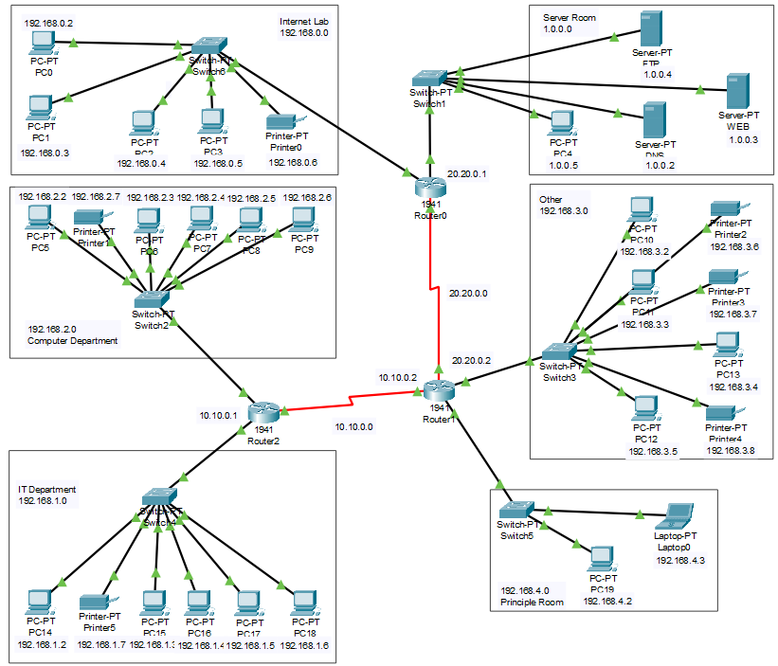

**Description:**

**Router 0:**

Router 0 is interconnected between internet lab, server room and router 1. In router 0, three port is used. GigabitEthernet0/0 relates to server room by 1.0.0.1 and GigabitEthernet0/1 is connected with internet lab by 192.168.0.1 so that all the device of server room and internet lab can connect with each other and access the internet via a shared connection. And Serial0/1/0 port in connected with router 1 so that and the devices of router 1 can connect with router 0 devices.

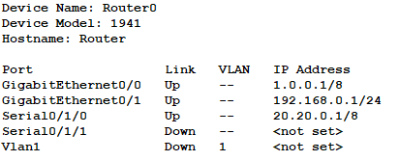

**Internet Lab:**

We set the IP address 192.168.0.0 for this Internet Lab section. We set the IP address 192.168.0.1 for the router as well as the gateway IP address. We use four PCs and a printer for this section. We connect them through a switch. For the four PCs, we set the IP addresses, respectively, as 192.168.0.2, 192.168.0.3, 192.168.0.4, and 192.168.0.5. And we set the IP address to 192.168.0.6 for the printer. We set 1.0.0.2 as the DNS. And the switch connects with router0 through the 0/1 port.

**Server Room:**

We set the IP address of 1.0.0.0 for this server room section. We set the IP address 1.0.0.1 for the router as well as the gateway IP address. We use one PC and three servers. We connect them through a switch. The servers are FTP, WEB, and DNS. We set the IP address to 1.0.0.2 for the DNS server. We set an IP address of 1.0.0.3 for the Web server. We set the IP address to 1.0.0.4 for the FTP server. And finally, we set the IP address to 1.0.0.5 for the PC. The switch connects with router0 through the 0/0 port.

**Router 1:**

Router 1 functions as the primary gateway for this network. It is equipped with four IP addresses assigned to different ports, enabling the routing of traffic across the subnetworks. For instance, if a device on the 20.20.0.0 network intends to communicate with a device on the 10.10.0.0 network, the traffic is directed to Router 1. Subsequently, Router 1 efficiently forwards this traffic to the appropriate device on the 10.10.0.0 network. This seamless traffic routing ensures that all devices within this private network can connect with each other and access the internet via a shared connection.

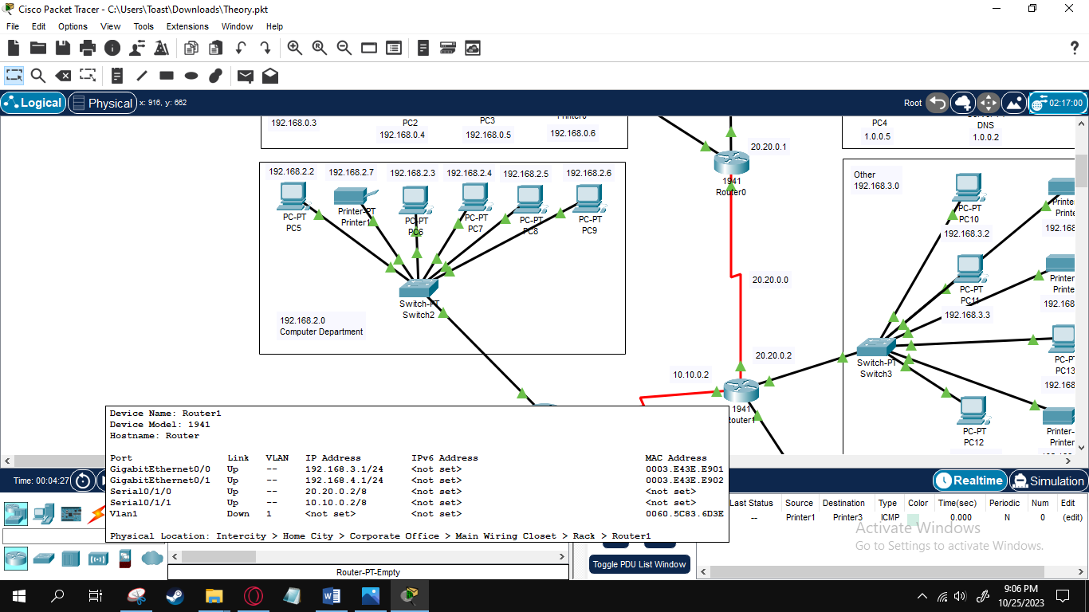

**Other:**

The computers and printers within the 'Other' category are interconnected through a single switch. These devices are configured with a default gateway set to 192.168.3.1 and a subnet mask of 255.255.255.0, creating a subnet of 192.168.3.0. Additionally, these devices retrieve DNS information from the 1.0.0.2 DNS server located in the server room. The switch acts as the link between the gateway router (Router 1) and the devices in 'Other,' facilitating their accessibility and interaction with other devices in the network, as well as granting them internet connectivity.

**Principal Room:**

Within the principal room, there are a computer and a laptop connected to a switch. These devices are identified within the 192.168.4.0 subnet, accompanied by a subnet mask of 255.255.255.0 and a default gateway of 192.168.4.1. Similar to the devices in 'Other,' these devices retrieve DNS information from the 1.0.0.2 DNS server. They possess the capability to connect with other devices on the network and are accessible for seamless data transmission.

**Router 2:**

1941 Router2 is used here. This is a router that connects the Computer Department (192.168.2.0) and IT Department (192.168.1.0) subnetworks to the Internet and then it flows to 1941 Router1 (20.20.0.2). It allows users in both departments to access the Internet and other online resources. It bridges the Computer Department and IT Department to the digital universe, granting them the ability to harness the Internet's power while concurrently safeguarding against threats and ensuring swift and secure data transfer. Without a router, the network becomes defenseless against external threats, leaving it open to attacks and unauthorized access. A router prevents problems by making sure devices in one department don't clash with those in the other due to overlapping IP addresses.

**IT department:**

The IT Department subnetwork, situated at 192.168.1.0, is the core of the organization's information technology infrastructure. It comprises PCs utilized by IT personnel, a dedicated printer for their use, and network connectivity facilitated by Switch-P. Furthermore, it forms a vital link to the Computer Department subnetwork through Switch4, enabling seamless collaboration and resource sharing. Router2 serves as the gateway to the Internet for both the IT and Computer Departments, ensuring connectivity and network management across the organization.

**Computer Department:**

The Computer Department subnetwork, situated at 192.168.2.0, houses a range of devices including PC-PT computers for students and faculty, CPT computers designated for teaching assistants and professors, along with Printer PT for general use and for teaching staff. These devices are interconnected through a central network switch. Notably, Switch2 establishes a critical connection to the IT Department subnetwork, allowing for efficient collaboration and resource sharing between the Computer and IT Departments, serving as a fundamental hub for the organization's academic and administrative technology needs.